MASTER ENCYCLOPEDIA OF THE 108 DIVYA DESAMS

BATCH 6A: THONDAI NAADU (SHRINES #86 TO #90)

DIVYA DESAM #86: THIRUVALLUR (THIRUVEVVUL)

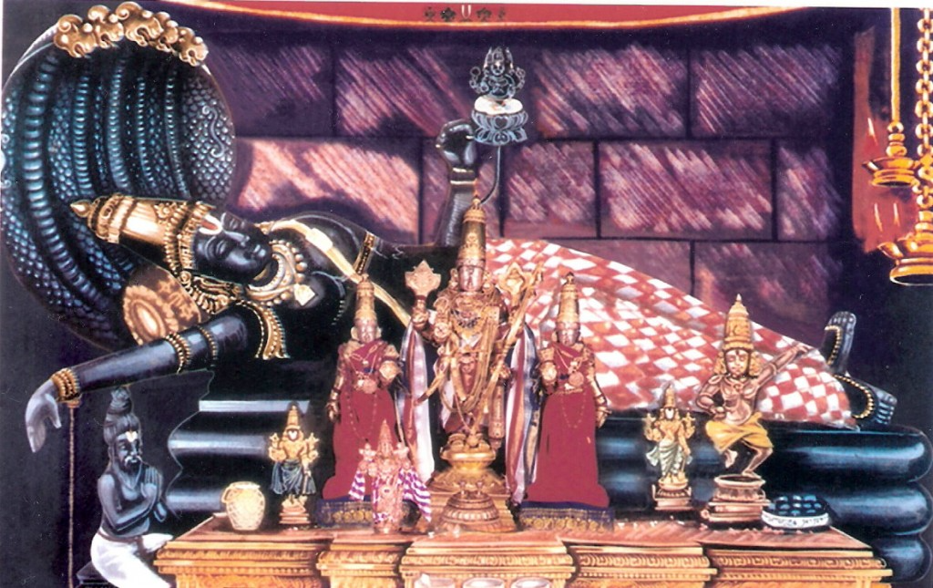

Sri Vaidhya Veeraraghava Perumal Swamy Temple
4.7 star rating4.7
🛕 Hindu temple
Closed Opens at 4.00 pm
Sri Vaidhya Veeraraghava Perumal Swamy TempleClick to open side panel for more information

1. Basic Shrine Profile
- Divya Desam Serial Number & Name: #86 — Thiruvallur (Thiruvevvul / Sri Veeraraghavaswamy Temple)
- Traditional Region: Thondai Naadu
- Geographical Location: Tiruvallur District, Tamil Nadu. Approximately 45 km west of Chennai on the Chennai-Arakkonam rail corridor.
- Sanctum Tower (Vimanam): Vijayakoti Vimanam
- Sacred Water Body (Theertham): Hridhayathaapa Naasini Pushkarini
- Sthala Vriksham: Shenbagam (Champaka)
- Sanctum Posture & Orientation: Kidantha Thirukkolam (Bhujanga Sayanam / Reclining posture facing East on Adisesha).

2. Deities & Consorts Breakdown
Entity | Name & Script | Etymology / Sthala Significance
Moolavar | Veeraraghavan / Evvul Kidanthaan  (வீரராகவன் / எவ்வுள் கிடந்தான்)  Sanskrit: ஶ்ரீ வீரராகவ பெருமாள் | Derived from the divine query "Evvul?" ("In which place shall I rest?"). He answered the sage's hospitality by lying down in the hermit's hut.
Moolavar Consorts | Kanakavalli Thaayar / Vasumathi  (கனகவல்லித் தாயார்) | Named Vasumathi as the daughter of King Dharmasena, later recognized as the manifestation of Mahalakshmi (Kanakavalli).
Urchavar | Vaidya Veeraraghavan  (வைத்திய வீரராகவன்) | The Divine Supreme Healer who cures chronic physical and spiritual illnesses (Bhavaroga).
Urchavar Consorts | Kanakavalli Thaayar | Present alongside Urchavar during all external processions and Brahmotsavam events.
Garbhagriha Layout | Single Consort Shrine Structure | Moolavar reclines in solitary majesty; Thaayar has a dedicated standalone shrine within the inner prakaram to preserve her independent mediation role (Purusakaram).

3. Complete Sthala Puranam, Miracles & Historic Milestones
- Sthala Puranam & Miracles: Sage Salihotra performed severe penance at this place, taking a vow to feed a guest before consuming his daily meal of pounded grain flour. Lord Vishnu tested him by arriving as an aged, hungry Brahmin. Salihotra offered his entire meal. The guest requested more, and Salihotra gave his own portion as well. The Brahmin then asked in Tamil, "Evvulul Kidanpadhu?" ("In which place shall I sleep?"). Salihotra pointed to his humble hut. The Lord reclined inside the hut and transformed into His divine form as Veeraraghavan, blessing Salihotra with salvation and granting the sacred water body the power to relieve all human ailments.
- Prathyaksham: Manifested directly to Sage Salihotra and King Dharmasena.
- Historical Timeline & Epigraphy:
  - Construction Era: Earliest structures date back to the 8th–9th century Pallava Dynasty.
  - Renovations & Patrons: Substantially expanded by Chola kings and later governed under the administrative stewardship of the Ahobila Mutt.
  - Invasions & Protection: Survived regional conflicts during the Carnatic Wars; temple administrative control was formally entrusted to the 44th Pontiff of Sri Ahobila Mutt.
- Literature References: Mentioned in the Markandeya Purana under Tondaimandala Mahatmyam.

4. Pasuram Details & Azhwar Mangalasasanam
- Total Pasurams: 12 Pasurams
- Azhwars Who Sang Praises: Thirumangai Azhwar (11 Pasurams), Thirumazhisai Azhwar (1 Pasuram).

Representative Pasuram — Thirumangai Azhwar
- Original Tamil:எவ்வெள் கிடந்த எம்மான் உலகேழும்,
உய்வண்ணம் பெற்ற தொருசீரான்,
மெய்வண்ணம் முற்று முழுதுணர்ந்தார் மேவாதே,
எவ்வண்ணம் நிற்பா ரிதே.
- Transliteration:
Evvul kidantha emmaan ulageazhum,
Uivannam petra thorusheeraan,
Meivannam mutru muzhudhunarndhaar mevaadhe,
Evvannam nirpaaridhe.
- Word-by-Word Meaning:
  - Evvul kidantha emmaan: My Lord who reclines at Thiruvevvul
  - Ulageazhum: All the seven worlds
  - Uivannam petra: Attained the means of redemption
  - Thorusheeraan: Possessing matchless, radiant qualities
  - Meivannam: The absolute truth of ultimate reality
  - Nirpaaridhe: How can anyone exist without contemplating Him?
- Theological Significance: Emphasizes absolute surrender (Saranagathi) to the Lord who actively seeks out the jiva to remove bodily and mental affliction.

5. Visuals & Media References
- Visual Markers:
  - Rajagopuram: 7-tiered soaring gateway facing East along the tank street.
  - Moolavar Form: Massive reclining deity on Adisesha with His right hand placed on Sage Salihotra's head.
  - Thaayar Form: Seated Padmasana icon in a separate shrine holding lotus buds.
  - Urchavar Form: Processional deity carrying five weapons (Panchayudha).
- Literature & Video References:
  - Literature: Project Madurai — Thirumangai Azhwar Periya Thirumozhi
  - Video Queries: Search YouTube for "Velukkudi Krishnan Thiruvevvul Upanyasam" or "Thiruvallur Veeraraghavaswamy Brahmotsavam".

DIVYA DESAM #87: THIRUKACHOOR (THIRUKACHI NAMBI / AADHI KACHI)

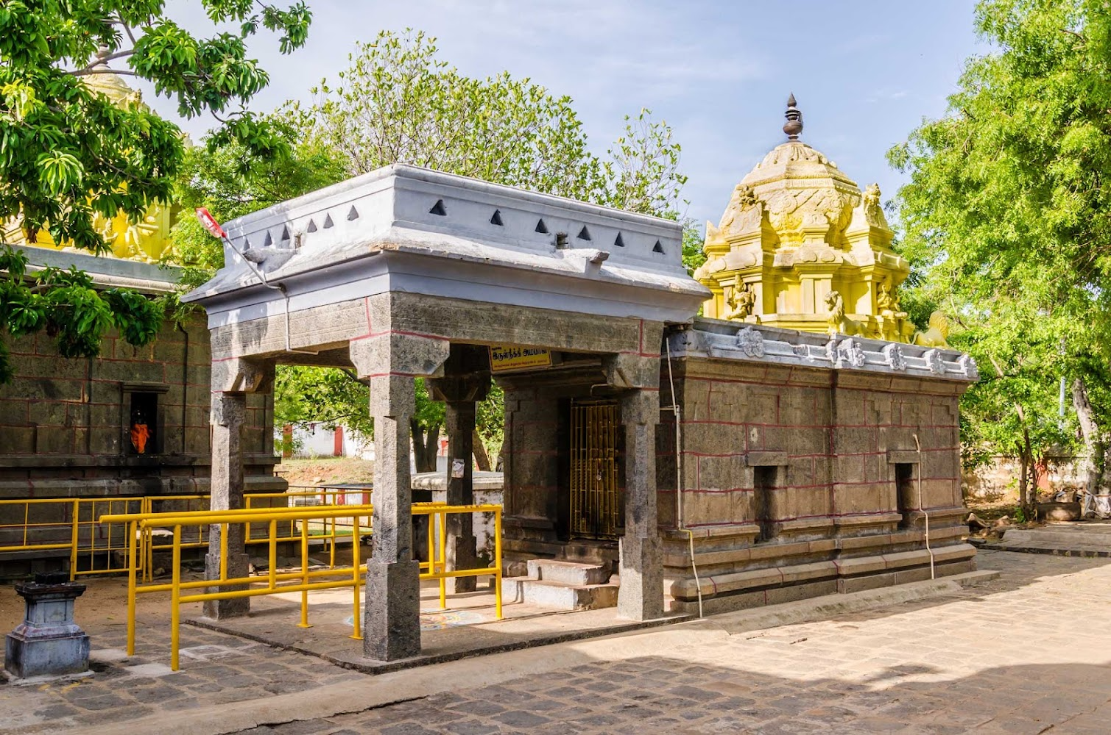

Arulmigu Maruntheeswarar Temple
4.8 star rating4.8
🛕 Hindu temple
Closed Opens at 4.45 pm
Arulmigu Maruntheeswarar TempleClick to open side panel for more information (Note: The Divya Desam sanctum is housed in the nearby historic Sri Karunakara / Thirukachoor Vishnu Shrine complex at Singaperumal Koil / Thirukachoor)

1. Basic Shrine Profile
- Divya Desam Serial Number & Name: #87 — Thirukachoor (Karunakara Perumal / Kachi Naadu)
- Traditional Region: Thondai Naadu
- Geographical Location: Chengalpattu District, Tamil Nadu. Situated 2 km off the Chennai-GST Road near Singaperumal Koil.
- Sanctum Tower (Vimanam): Gabadhakara Vimanam / Periya Vimanam
- Sacred Water Body (Theertham): Akshaya Theertham / Gaja Pushkarini
- Sthala Vriksham: Fig Tree (Athi)
- Sanctum Posture & Orientation: Nindra Thirukkolam (Standing posture facing North).

2. Deities & Consorts Breakdown
Entity | Name & Script | Etymology / Sthala Significance
Moolavar | Karunakara Perumal  (கருணாகர பெருமாள்)  Sanskrit: ஶ்ரீ கருணாகர பெருமாள் | "Ocean of Compassion" who showered grace upon Lord Brahma and Indra during their penance.
Moolavar Consorts | Padmamani Thaayar / Ekambavalli  (பத்மமணி தாயார்) | Named after her lotus-like purity and association with the primordial flora of the hillock.
Urchavar | Abheesta Varadhan  (அபீஷ்ட வரதன்) | "The Bestower of Desired Boons" to devotees seeking spiritual progress.
Urchavar Consorts | Padmamani Thaayar | Accompanies the deity during sacred processions.
Garbhagriha Layout | Dual Consort Presence | Moolavar flanked by Sridevi and Bhudevi within the primary sanctum.

3. Complete Sthala Puranam, Miracles & Historic Milestones
- Sthala Puranam & Miracles: Indra and the Devas performed severe penance at this site to regain their celestial sovereignty. Lord Vishnu manifested as Karunakaran, showering His boundless grace (Karuna) to restore their lost authority and protect their sacrificial rituals from interference.
- Prathyaksham: Manifested to Lord Brahma, Indra, and the Saptharishis.
- Historical Timeline & Epigraphy:
  - Construction Era: Early Chola and Pallava brick-to-stone transformation phase (9th–10th century CE).
  - Inscriptions: Detailed Chola epigraphs record land donations by Kulothunga Chola I for daily oil lamps and rice offerings (Amudhubadi).
- Literature References: Recorded in local sthala puranams and Thondaimandala Divya Desam chronicles.

4. Pasuram Details & Azhwar Mangalasasanam
- Total Pasurams: 1 Pasuram
- Azhwars Who Sang Praises: Thirumangai Azhwar (1 Pasuram).

Representative Pasuram — Thirumangai Azhwar
- Original Tamil:கச்சியுள் ளாய் கச்சி வெஃகாவுள்ளாய் நின்றாய்,
இச்சை யுளாயெங்க ளுச்சி யுளாய்,
மெச்சிய முப்பத்து மூவர் அமரர்க்கு,
நச்சமு தூட்டிய நாதனே!
- Transliteration:
Kachiyul llaai kachi vekkaavullaai ninraai,
Ichai yulaayenga luchi yulaai,
Mechiiya muppathu mooovar amararkku,
Nachamu thootiya naadhane!
- Word-by-Word Meaning:
  - Kachiyul llaai: O Lord who resides in the Kanchi region / Thirukachoor
  - Muppathu mooovar amararkku: For the thirty-three crore celestials
  - Amudhu ootiya: Who fed the divine nectar of grace
  - Naadhane: O Supreme Master!
- Theological Significance: Proclaims the Lord's absolute accessibility (Saulabhyam) in taking residence in human settlements to nourish devotees.

5. Visuals & Media References
- Visual Markers:
  - Rajagopuram: 3-tiered compact Dravidian gateway facing the sacred tank.
  - Moolavar Form: Standing majestic image with Abhaya Hasta and Varada Hasta.
  - Thaayar Form: Seated figure with fully blossomed lotus flowers.
  - Urchavar Form: Elegant metal icon carrying a discus and conch.
- Literature & Video References:
  - Literature: Dravida Veda — Azhwar Pasuram Archives
  - Video Queries: Search YouTube for "Thirukachoor Karunakara Perumal Temple" or "Thondai Naadu Divya Desam Lectures".

DIVYA DESAM #88: THIRUKADALMALLAI (MAHABALIPURAM)

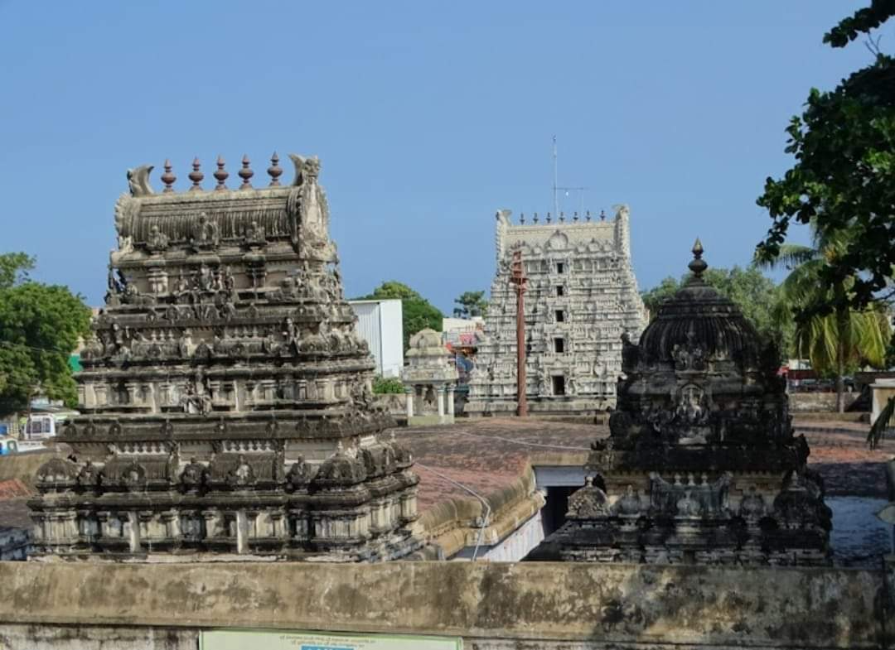

Arulmigu Sri Sthala Sayana Perumal Temple
4.6 star rating4.6
🛕 Hindu temple
Closed Opens at 3.00 pm
Arulmigu Sri Sthala Sayana Perumal TempleClick to open side panel for more information

1. Basic Shrine Profile
- Divya Desam Serial Number & Name: #88 — Thirukadalmallai (Mahabalipuram / Sthala Sayana Perumal Temple)
- Traditional Region: Thondai Naadu
- Geographical Location: Chengalpattu District, Tamil Nadu. Situated in the heart of historic Mamallapuram along the East Coast Road.
- Sanctum Tower (Vimanam): Ganganakondaan Vimanam / Ananda Vimanam
- Sacred Water Body (Theertham): Pundareeka Pushkarini / Pundarika Saras
- Sthala Vriksham: Punnai (Alexandrian Laurel)
- Sanctum Posture & Orientation: Kidantha Thirukkolam (Reclining directly on the floor/ground facing East without Adisesha).

2. Deities & Consorts Breakdown
Entity | Name & Script | Etymology / Sthala Significance
Moolavar | Sthala Sayana Perumal  (ஸ்தல சயன பெருமாள்)  Sanskrit: ஶ்ரீ ஸ்தலஸயன பெருமாள் | "Lord reclining directly upon the bare earth" (Sthala) instead of His usual serpent bed (Adisesha).
Moolavar Consorts | Nilamangai Thaayar  (நிலமங்கைத் தாயார்) | Represents Mother Earth (Bhudevi) in her supreme, independent form.
Urchavar | Ulauyyuva Perumal / Ahobila Varadhan  (உலகுய்யவந்த பெருமாள்) | "The Lord who descended to redeem the entire universe."
Urchavar Consorts | Sri Bhoo Devis | Flanked by both consorts for public processions.
Garbhagriha Layout | Unique Floor Reclining | Moolavar reclines directly on the ground floor without serpent coils. Sage Pundarika is sculptured near His lotus feet offering a lotus blossom.

3. Complete Sthala Puranam, Miracles & Historic Milestones
- Sthala Puranam & Miracles: Sage Pundarika collected golden lotus flowers from his pond to offer to Lord Vishnu reclining on the Milk Ocean. Finding the ocean blocking his path, the persistent sage began scooping out the sea water with a small shell. Touched by his devotion, Lord Vishnu appeared as an old man, asked for food, and sent Pundarika to fetch it. When the sage returned, he saw the Lord reclining directly on the bare ground, adorned with the very lotus flower Pundarika had plucked.
- Birthplace of Boodhath Azhwar: Thirukadalmallai is the sacred Avathara Sthalam (birthplace) of Boodhath Azhwar, who incarnated in a lotus flower in the temple tank.
- Historical Timeline & Epigraphy:
  - Construction Era: 7th–8th century Pallava rock-cut architecture, later expanded into a structural temple complex by Vijayanagara and Nayak rulers.
  - Inscriptions: Pallava and Chola inscriptions document royal endowments for maritime travelers and local temple worship.
- Literature References: Featured in Pallava epigraphs and classical Tamil literature documenting Mamallapuram's maritime history.

4. Pasuram Details & Azhwar Mangalasasanam
- Total Pasurams: 27 Pasurams
- Azhwars Who Sang Praises: Thirumangai Azhwar (26 Pasurams), Boodhath Azhwar (1 Pasuram).

Representative Pasuram — Boodhath Azhwar
- Original Tamil:தமருகமு றுவண்ண மாயினானும்
தரணியும் வானமும் தானாயினானும்
அமரர்களடி போற்ற நின்றானும்
கடல்லலைச் சயனத்தே யுறங்கும் மாயோனே.
- Transliteration:
Thamarugamu ruvanna maayinaanum
Tharaniyum vaanamum thaanayinanaum
Amarargaladi potra ninraanum
Kadalmallaich sayanathe yurangum maayone.
- Word-by-Word Meaning:
  - Thamarugam: The Form loved by His devotees
  - Tharaniyum vaanamum: Earth and the heavens
  - Kadalmallai sayanathe: Reclining at the seaside shrine of Kadalmallai
  - Urangum maayone: The wondrous Supreme Lord resting in yogic sleep
- Theological Significance: Celebrates the Lord's supreme cosmic nature alongside His intimate accessibility at this seaside shrine.

5. Visuals & Media References
- Visual Markers:
  - Rajagopuram: Distinctive 7-tiered tower showcasing Vijayanagara architectural influences.
  - Moolavar Form: Unique floor-reclining image with one hand resting on His chest (Jnana Mudra).
  - Thaayar Form: Separate shrine featuring Nilamangai Thaayar in seated posture.
  - Urchavar Form: Metallic icon holding lotus buds alongside Sage Pundarika.
- Literature & Video References:
  - Literature: Koyil.org — Thirukadalmallai Sthala Puranam
  - Video Queries: Search YouTube for "Thirukadalmallai Sthala Sayana Perumal" or "Boodhath Azhwar Avathara Sthalam".

DIVYA DESAM #89: THIRU NILATHINGAL THUNDAM (KANCHIPURAM)

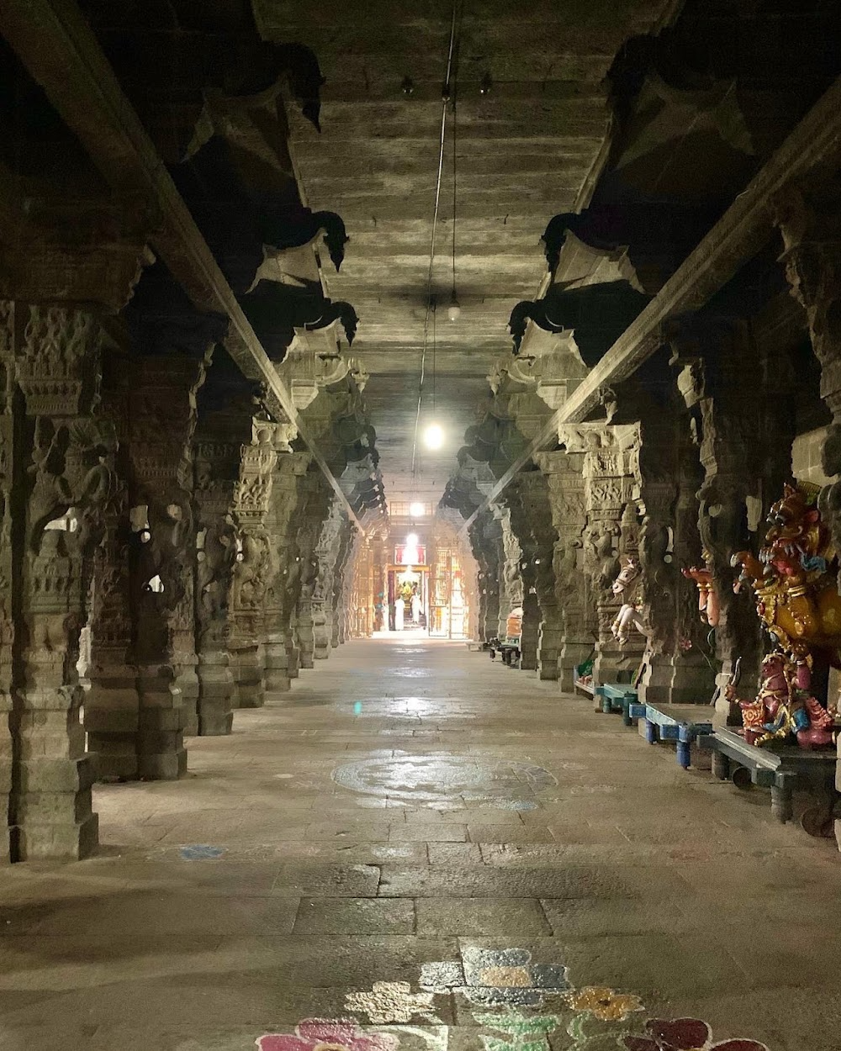

Divya Desam-49 Thiru Nilathingal Thundam Temple
4.8 star rating4.8
🛕 Hindu temple
Closed Opens at 4.00 pm
Divya Desam-49 Thiru Nilathingal Thundam TempleClick to open side panel for more information (Located inside the Ekambareswarar Temple complex)

1. Basic Shrine Profile
- Divya Desam Serial Number & Name: #89 — Thiru Nilathingal Thundam (Nilathingal Thundathan / Kanchipuram)
- Traditional Region: Thondai Naadu
- Geographical Location: Kanchipuram town, Tamil Nadu. Enclosed within the outer prakaram of the Ekambareswarar Temple complex.
- Sanctum Tower (Vimanam): Purushasooktha Vimanam
- Sacred Water Body (Theertham): Chandra Pushkarini
- Sthala Vriksham: Mango Tree (Maamaram of the main complex)
- Sanctum Posture & Orientation: Nindra Thirukkolam (Standing posture facing West).

2. Deities & Consorts Breakdown
Entity | Name & Script | Etymology / Sthala Significance
Moolavar | Nilathingal Thundathan / Chandrasooda Perumal  (நிலத்திங்கள் துண்டத்தான்)  Sanskrit: ஶ்ரீ சந்த்ரசூட பெருமாள் | Named after the cool, moon-like rays radiated by Lord Vishnu to cool Goddess Parvathi during her intense penance.
Moolavar Consorts | Nerthanthi Thaayar / Chandra Choodavalli  (நேர்தாந்தி தாயார்) | Manifested to provide cooling protection to all meditating souls.
Urchavar | Nilathingal Thundathan | Represented within the inner shrine enclosure.
Urchavar Consorts | Nerthanthi Thaayar | Flanks the processional deity.
Garbhagriha Layout | Unique Intra-Saivite Enclosure | The Vishnu sanctum is positioned in the first prakaram (Nirruthi direction) of the Ekambareswarar Shiva temple. Priest duties are performed by traditional Vaikhānasa/Pāncharātra archakas.

3. Complete Sthala Puranam, Miracles & Historic Milestones
- Sthala Puranam & Miracles: When Parvathi performed penance under the Mango tree, Lord Shiva tested her by launching intense heat. Goddess Parvathi prayed to her brother, Lord Vishnu. Vishnu beamed cool moon-like rays from His crescent-adorned radiance to alleviate the heat and protect her penance. Thus He earned the title Nilathingal Thundathan ("Lord of the cool moonbeam snippet").
- Prathyaksham: Manifested to Goddess Parvathi and Lord Shiva.
- Historical Timeline & Epigraphy:
  - Construction Era: Co-eval with early Pallava rock and brick structures of Kanchipuram (6th–8th century CE).
  - Epigraphy: Recorded in early Pandyan and Chola inscriptions acknowledging both Vaishnava and Saiva shrines within the sacred precinct.
- Literature References: Detailed in the Kanchi Sthala Puranam and Divya Prabandham commentaries.

4. Pasuram Details & Azhwar Mangalasasanam
- Total Pasurams: 1 Pasuram
- Azhwars Who Sang Praises: Thirumazhisai Azhwar (1 Pasuram).

Representative Pasuram — Thirumazhisai Azhwar
- Original Tamil:நீலத் திங்கள் துண்டத்தாய் நின்றானை நின்கண்ணே,
காலத் தினாற் கண்டுகொண்டேனை - மேலைத்,
தவறாமைத் தான்வந்து தான்முன்னே நின்றான்,
அவனாளா யேற்கமைந்த வன்பு.
- Transliteration:
Neelath thingal thundathaai ninraanai ninkanne,
Kaalath thinaar kandugondhenai - mealaith,
Thavaraamaith thaanvandhu thaanmunne ninraan,
Avanaalaa yerkamaindha vanbu.
- Word-by-Word Meaning:
  - Neelath thingal thundathaai: O Lord who stands at Nilathingal Thundam
  - Kandugondhenai: I have realized You within my consciousness
  - Thaanmunne ninraan: He came and stood before me graciously
  - Vanbu: Absolute divine love
- Theological Significance: Illustrates how the Lord transcends sectarian boundaries to protect those performing righteous tapas.

5. Visuals & Media References
- Visual Markers:
  - Rajagopuram: Enclosed within the main 59-meter tall Southern Gopuram of the Ekambareswarar complex.
  - Moolavar Form: Standing deity facing West, holding the Conch and Discus.
  - Thaayar Form: Small, elegant relief image within the main sanctum.
  - Urchavar Form: Sacred metal image housed in a designated metallic chest/shrine.
- Literature & Video References:
  - Literature: Project Madurai — Naalayira Divya Prabandham Archives
  - Video Queries: Search YouTube for "Nilathingal Thundam Perumal Kanchipuram" or "Kanchipuram Divya Desams Tour".

DIVYA DESAM #90: THIRUKARANAKARAM (KANCHIPURAM)

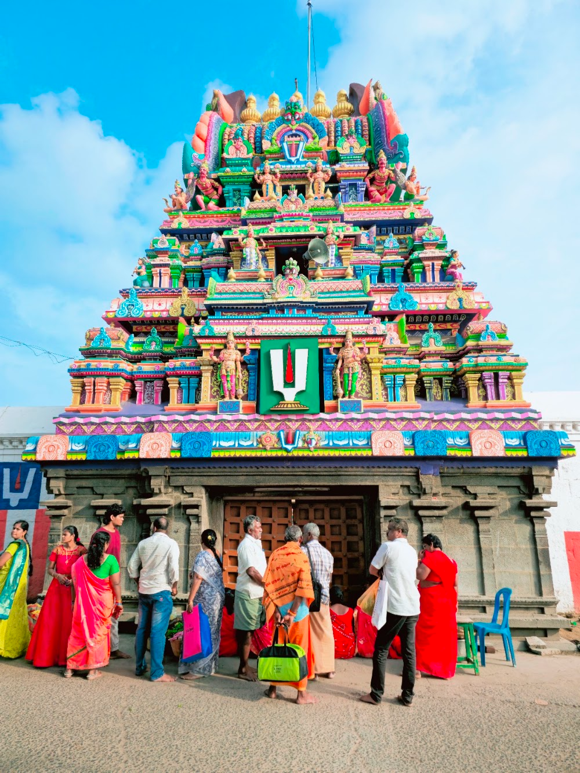

Sri Ulagalanda Perumal Devastanam Temple
4.7 star rating4.7
🛕 Hindu temple
Closed Opens at 5.00 pm
Sri Ulagalanda Perumal Devastanam TempleClick to open side panel for more information (Preserved inside the Ulagalandha Perumal Temple Complex)

1. Basic Shrine Profile
- Divya Desam Serial Number & Name: #90 — Thirukarana (Karunakara Perumal / Kanchipuram)
- Traditional Region: Thondai Naadu
- Geographical Location: Enclosed inside the Sri Ulagalandha Perumal Temple complex near Kanchipuram bus stand, Tamil Nadu.
- Sanctum Tower (Vimanam): Ramana Vimanam
- Sacred Water Body (Theertham): Akraya Theertham
- Sthala Vriksham: Nagalingam Tree
- Sanctum Posture & Orientation: Nindra Thirukkolam (Standing posture facing South).

2. Deities & Consorts Breakdown
Entity | Name & Script | Etymology / Sthala Significance
Moolavar | Karunakara Perumal  (கருணாகர பெருமாள்)  Sanskrit: ஶ்ரீ கருணாகர பெருமாள் | The embodiment of divine grace (Karuna) who bestows wisdom upon Sage Nikethana.
Moolavar Consorts | Padmamani Thaayar  (பத்மமணி தாயார்) | Symbolizes pure lotus-born devotion.
Urchavar | Karunakara Perumal | Small processional deity preserved within the Ulagalandha Perumal precinct.
Urchavar Consorts | Padmamani Thaayar | Positioned alongside Urchavar during temple festivals.
Garbhagriha Layout | Co-located Shrine Enclosure | Preserved as an independent sub-shrine along the third inner corridor of the Ulagalandha Perumal Temple complex.

3. Complete Sthala Puranam, Miracles & Historic Milestones
- Sthala Puranam & Miracles: Sage Nikethana performed tapas at this spot asking for true spiritual vision. Lord Vishnu appeared before him as Karunakara Perumal, imparting supreme spiritual knowledge (Jnana) and promising that whoever worships Him here will be freed from ignorance.
- Prathyaksham: Manifested to Sage Nikethana.
- Historical Timeline & Epigraphy:
  - Construction Era: 8th century Pallava era, later restructured during Chola and Vijayanagara periods.
  - Renovations: Integrated into the central Ulagalandha Perumal temple structure for protective preservation during medieval invasions.
- Literature References: Documented in medieval commentary literature (Idu 36000 Padi) of Vaidika Vaishnavism.

4. Pasuram Details & Azhwar Mangalasasanam
- Total Pasurams: 1 Pasuram
- Azhwars Who Sang Praises: Thirumangai Azhwar (1 Pasuram).

Representative Pasuram — Thirumangai Azhwar
- Original Tamil:நீரகம் வேகாகோள நிலத்திங்கள் துண்டமகம்,
காரகம் ஊரகம் கார்க்கோளக் காரவானம்,
பேரகம் காட்டும் பெருமானை என்நெஞ்சம்,
கூரகம் காட்டும் குறித்து.
- Transliteration:
Neeragam vegaagola nilathingal thundamagam,
Kaaragam ooragam kaarkkolak kaaravaanam,
Peeragam kaattum perumaanai ennenjam,
Kooragam kaattum kurithu.
- Word-by-Word Meaning:
  - Kaaragam: Thirukaaragam shrine
  - Ooragam: Thiru Ooragam (Ulagalandha Perumal)
  - Kaaravaanam: Thirukaaravaanam
  - Perumaanai: The Supreme Lord who resides in all these Kanchi shrines
  - Ennenjam: My mind continuously contemplates Him
- Theological Significance: Thirumangai Azhwar weaves multiple Kanchipuram Divya Desams into a single hymn, emphasizing that the Lord's forms are varied manifestations of one Supreme Being.

5. Visuals & Media References
- Visual Markers:
  - Rajagopuram: Main 3-tiered Gopuram of the Sri Ulagalandha Perumal Temple.
  - Moolavar Form: Standing deity facing South, displaying Abhaya Mudra.
  - Thaayar Form: Compact relief sculpture within the sanctum frame.
  - Urchavar Form: Metal icon holding the Panchayudha.
- Literature & Video References:
  - Literature: Dravida Veda — Thirumangai Azhwar Hymns
  - Video Queries: Search YouTube for "Ulagalandha Perumal Kanchipuram Sub Shrines" or "Thirukarana Perumal Temple".
Would you like to proceed with Batch 6B: Naduvu Naadu — Shrines #91 to #95 (Thiruvendhipuram, Thirukoilur, etc.)?

